PROJECT REPORT- PARKING LOT REHABILILTATION
Spray Patching, Sealcoat, Line Striping – July 19, 2020 - CURRENT
LOCATION: Lou’s Farm Mart, 2450 Bristol Pike, Bensalem PA 19020
REFERENCE: Parking Lot was experiencing Small Potholes, Fatigue Cracking, Surface Leveling, Asphalt Oxidation, Faded Line Stripping.
HISTORY: Lou’s Farm Market, 7 day a week operation, requested alternative parking lot rehabilitation techniques allowing continued Market operation hours while meeting their budget that costly new asphalt milling and over-lay, would not allow.
PROJECT G.C. Patch Management, Inc. provided the solution by addressing the large distressed areas of fatigue cracking through Spray Patching surface treatments and rolled with Pneumatic roller providing an aesthetic, tight to the existing surface, providing smooth transition for pedestrian traffic. Following surface repairs two coats of Asphalt Emulsion Sealcoat was applied. Line Stripping applications: Parking-stalls, Handicap, Directional Arrows. Sealcoat and Line stripping applications were completed in 3 segments allowing the Market to continue normal operation hours.
REHABILITATION PROCESS:
SPRAY PATCHING SURFACE TREATMENT, ROLLED TIGHT TO ASPHALT SURFACE, Sealcoat (2-coats), Line Stripping
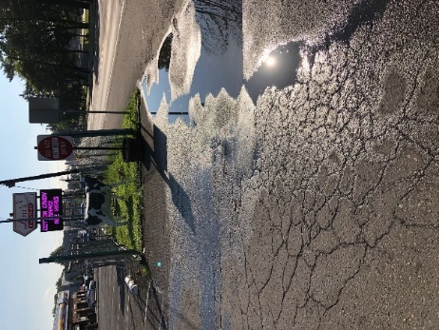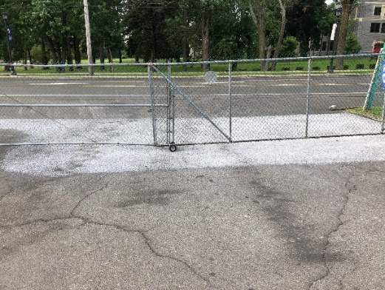

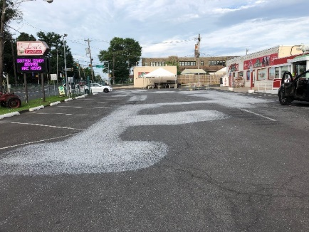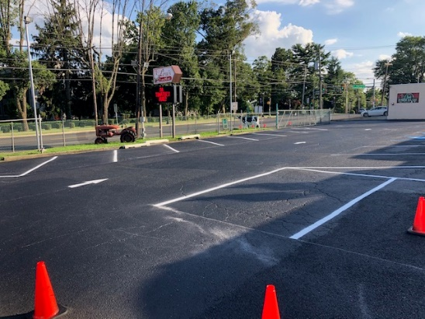
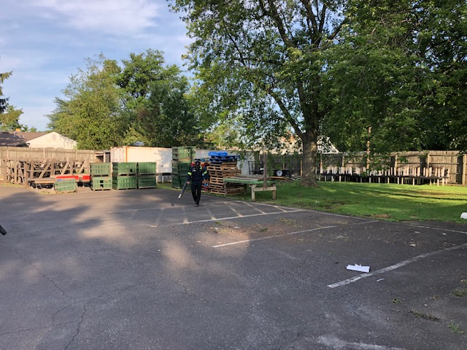
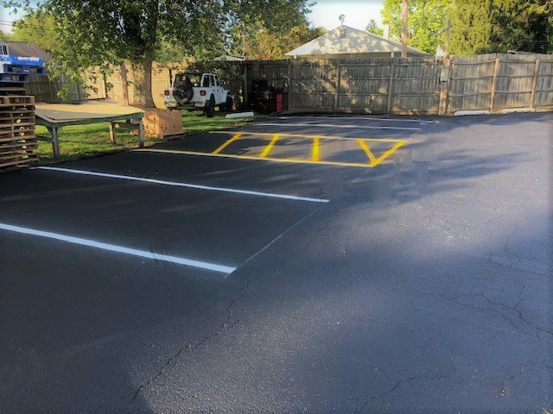 Before After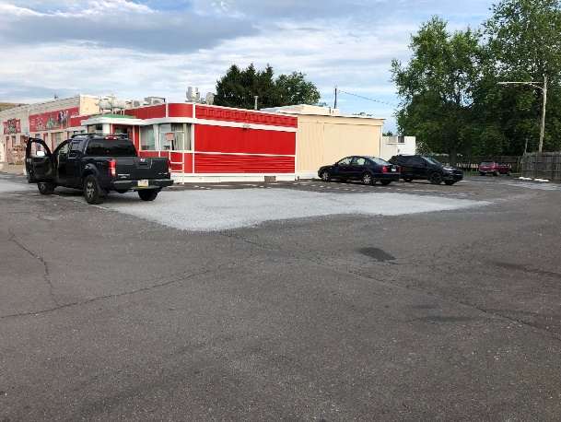 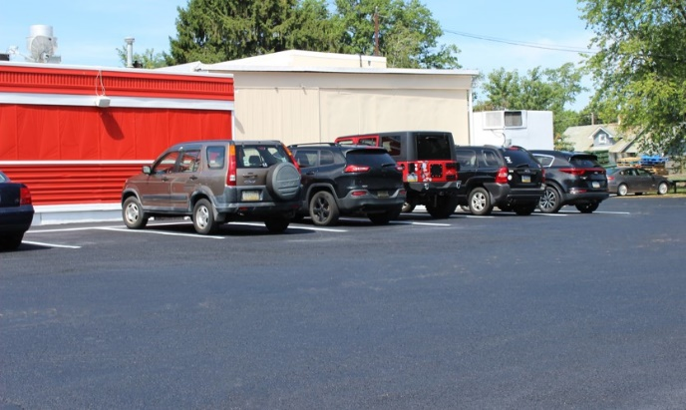
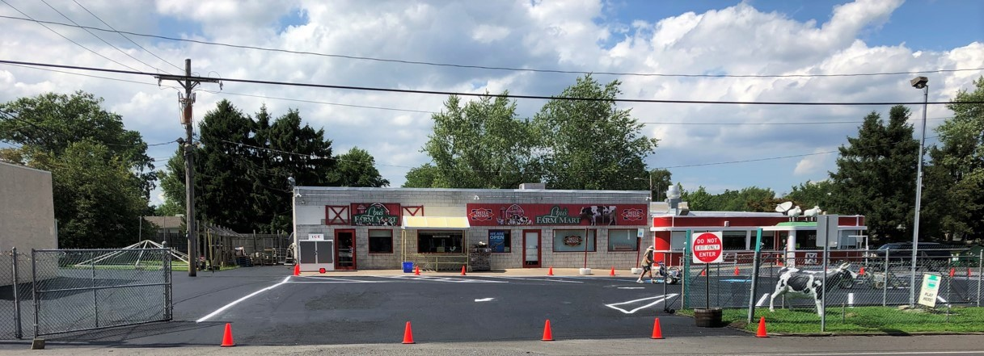
RESULTS: Project was completed in 3 phases which allowed normal business operations to continue throughout the rehabilitation process without loss of revenue. Rehabilitation project was completed on time and within budget for a fraction of the cost of traditional mill and pave.
Customer Reaction:
“We needed to address our aging parking lot but didn’t have a huge budget.
Patch Management made our lot look great again! Our customers love it!!”
Lou’s Farm Mart General Manager, M.T.

