**A Pothole Killer Case Study**

RHODE ISLAND DOT



From the *Rhode Island Department of Transportation Quarterly Report, January-March, 2016*

**Key Accomplishments**

**Improved Operations** (page 9)

…

* Potholes – The steps the department has taken to address potholes are bearing fruit. Our Maintenance Department made use of new “pothole killer” direct injection technology for the first time this winter. Thanks to those efforts and the focus last summer on key pothole problem areas, pothole claims are down more than 70% as compared to the five year average. Importantly, the severity of this winter season was average as compared to the past five years.

…

**Maintenance and Winter Operations** (pages 30-31)

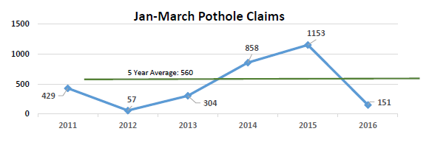

This past winter, RIDOT received 151 pothole claims from motorists for reimbursements of repair costs resulting from pothole damage on the state’s roads – **a drop of more than 70 percent compared to the previous 5-year average.** Importantly, this winter was on par with the average winter seasons for the past 5 years. A similar sharp decline was observed in the number of pothole calls received at RIDOT’s Traffic Management Center, with the number of calls received in March 2016 only a quarter of the number of calls received in March 2015. These reductions can be attributed to:

* Less severe winter conditions compared to 2015. Past data does show some correlation between the Winter Severity Index (WSI) and the number of pothole claims and calls received in the corresponding winter season.
* In 2015, RIDOT implemented the services of 4 automated pothole patching trucks during the spring and summer months, and maintained the use of 2 of these trucks through the fall and winter months. These newer style trucks are able to make permanent pothole repairs in less time, with minimal disruption to motorists with the operator safely in the cab of the vehicle. The RIDOT Maintenance District Facilities assigned the pothole patching trucks to many of the known hotspot areas for potholes around the State.

**

*--------*

*Make Rhode Island’s Success your Success! Call to set up a presentation or a demonstration today.*

|  |  |  |
| --- | --- | --- |
| Brian J. Preski, Director  Government Affairs  Patch Management, Inc.  451 Tyburn Rd.  Fairless Hills, PA 19030 | PATRIOTIC GUNSLINGER3 | (215) 949-9400 (office)  (215) 740-7095 (cell)  (215) 949-3166 (fax)  [bjp@potholekillers.com](mailto:bjp@potholekillers.com) |