A Pothole Killer Case Study
The Wilkes-Barre Citizen’s Voice said it best:
“The pothole killer got the job done Saturday.”
“Passing motorists gave a literal thumbs-up to the pothole repairs, he said, noting that “overall, the residents were pleased.”

Pothole killer hits the streets in West Pittston
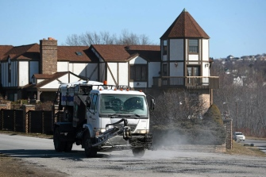
2/4/2017 - WEST PITTSTON — The pothole killer got the job done Saturday.
Many of the potholes created by an ongoing water line project in West Pittston are dead, or at least filled in and repaired, according to borough Mayor Tom Blaskiewicz.
The borough hired Bucks County-based Patch Management Inc. to “kill” potholes along Luzerne Avenue and surrounding streets impacted by the utility project, Blaskiewicz said. . .
On Saturday the pothole killer arrived. For 6½ hours a crew filled potholes using the machine’s environmentally friendly spray injection system, the mayor said.
“It went well,” Blaskiewicz said. “They did a tremendous job taking care of a lot of potholes.”
Passing motorists gave a literal thumbs-up to the pothole repairs, he said, noting that “overall, the residents were pleased.”
The cost of the pothole repairs was split between the borough and Pennsylvania American Water Company, according to Blaskiewicz.
The borough and the water company hope to finish the utility project by Memorial Day, he said.
--------
Make West Pittston’s Success your Success!

Call (215) 949-9400) to set up a presentation or demonstration today.

Patch Management, Inc.  451 Tyburn Rd.  Fairless Hills, PA 19030 | 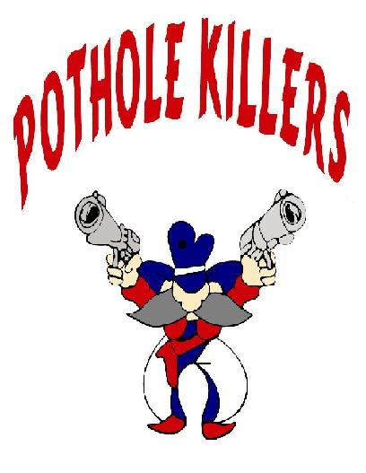 | (215) 949-9400 (office)

