FIELD REPORT- CONCRETE PARKING LOT REPAIRS
MASTIC APPLICATION – February 2020 - CURRENT
LOCATION: City of Rahway, Public Library, 2 City Hall Plaza
REFERENCE: Concrete Repairs, Garage Parking Area, ground floor
PROJECT G.C. Patch Management Inc. Fairless Hills PA

PRODUCT PLACEMENT: MASTIC Black, placed in severely distressed concrete areas. Repairs ranging from surface treatments to 4 Inches in Depth with exposed re-bar. Mastic applications where applied with temperatures exceeding 50 degrees and dry surface conditions. Approximately 3,200 SF of MASTIC was applied over a 2-day period by Patch Management Inc., using the new Cimline C-1 Mastic all in one application technology.
HISTORY: The city was faced with severely spalled concrete repairs in their Public Libraries concrete parking area exposing vehicles to potential repairs and possible liability issues for pedestrian traffic. The city received estimates for total concrete replacement that exceeded their budget restraints. It was determined that Mastic Repairs would provide a long-term solution until funding becomes available.
APPLICATION PROCESS:
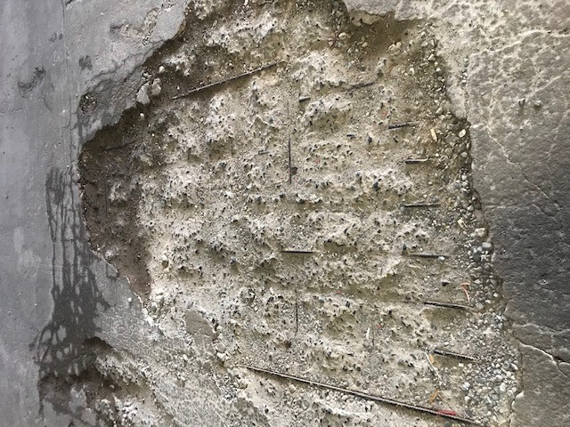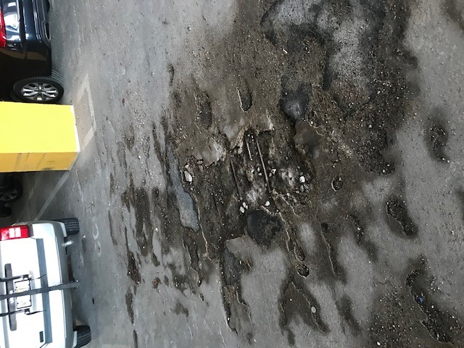
SURFACE PREPERATION: CLEAN & DRY
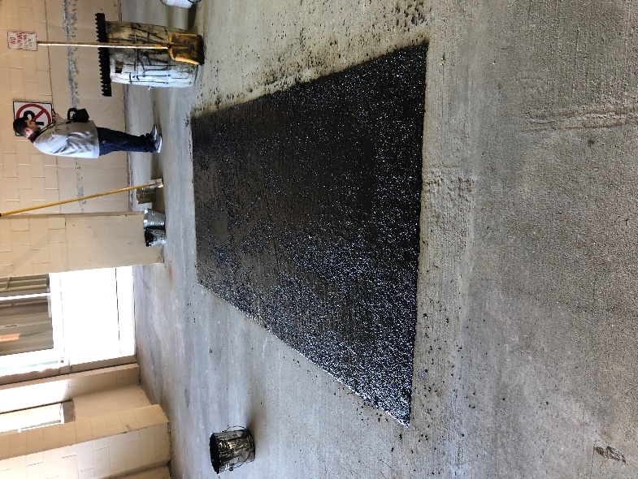
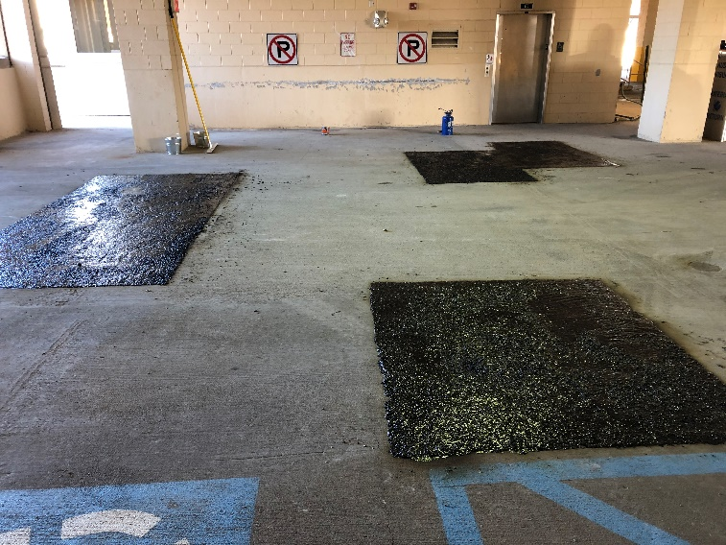
Application Binder material is heated in the C-1 OIL JACKETED MELTER 390 DEGREES
Aggregate was size ¼’’, clean and heated to 390 degrees in the C-1. PLACED OVER AND GRAVITY POURED ON REPAIR AREA. ASPHALT HAND RAKES ARE USED TO POSITION MATERIAL IN REPAIR AREA, RESULTING IN AN ASTATIC REPAIR, MOST IMPORTANTLY PROVIDING A LONG-TERM REPAIR MEETIG RIDE QUILITY STANDARDS.
RESULTS: Average size surface repairs ranged from 5 x 5 – 20-20 SF with average depth 1-4 inches. Project was completed in 2- days and on schedule, total 3,200 SF. “The technology of the C-1 provided an applicator with ability to meet large production needs and aggregate size for all application types”, from surface treatments to full depth. The C-1 features include two unique benefits, providing crack sealing applications and structural Patch applications all with ONE unit.
