FIELD REPORT- ROADWAY DELAMINATION SURFACE REPAIRS
MASTIC APPLICATION – OCTOBER 2019 - CURRENT
LOCATION: DELAWARE WATER GAP NATIONAL PARK, BUSHKILL PA., RT. 209 NORTH / SOUTH BOUND (Mile Markers 1-2, 3-4 and 5-6)
REFERENCE: SURFACE DELAMINATION REPAIRS IN ASPHALT ROADWAY. APPLICATIONS APPLIED BYE PATCH MANAGEMENT INC. FAIRLESS HILLS PA.
PROJECT G.C. J.D. BRAVO Company, Inc operates a Service-Disabled Veteran owned Small Business, (SDVOSB) as well as a Disadvantaged Small Business, (DBE-PA, NJ, VA, DC) and is a participant in the SBA8 (a) Business Development.

PRODUCT PLACEMENT: MASTIC Black- moderate climate, placed in distressed areas, requiring treatments beyond normal crack sealing and conventional remove and replace techniques. Mastic applications where applied with temperatures exceeding 40 degrees and dry surface conditions. Approximately 4,444 SF of MASTIC was applied over a 3-day period by Patch Management Inc., using the new Cim-line C-1 Mastic applicator technology.
HISTORY: Delaware Water Gap National Park was experiencing roadway delamination requiring repairs beyond conventional remove and replace techniques and costly new asphalt over-lay applications. Repairs consisted of areas as small as 2x2 and as large as 10 x10.
APPLICATION PROCESS:
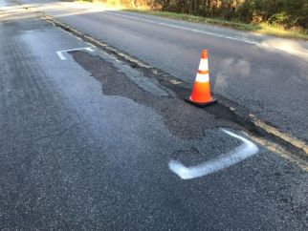
SURFACE PREPERATION: CLEAN & DRY

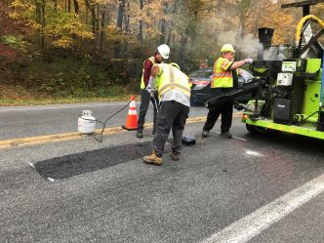
Application Binder material is heated in the C-1 OIL JACKETED MELTER TO 380 – 400 DEGREES
Aggregate was size ¼’’, clean and heated to 260 degrees in the C-1. PLACED OVER AND GRAVITY POURED ON REPAIR AREA and placed with box lute and straight bladed asphalt rake.
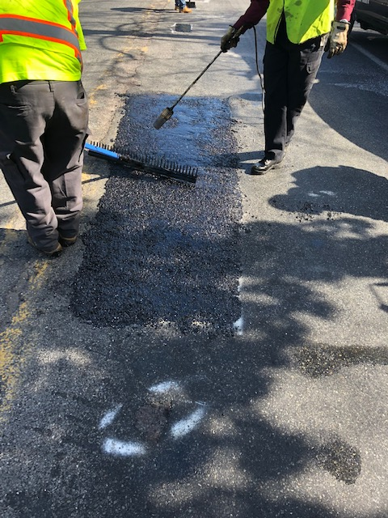
ASPHALT HAND RAKES ARE USED TO POSITION MATERIAL IN REPAIR AREA, RESULTING IN AN ASTATIC REPAIR, MOST IMPORTANTLY PROVIDING A LONG-TERM REPAIR MEETIG RIDE QUILITY STANDARDS.

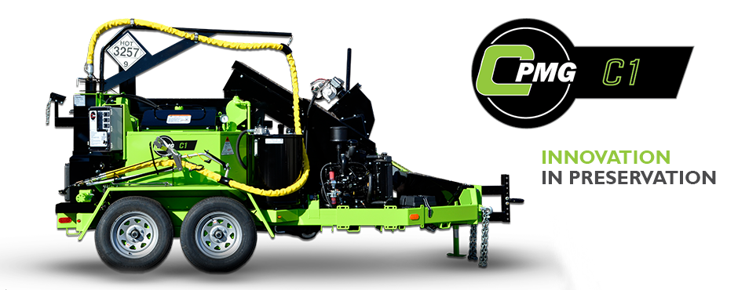

RESULTS:
Average size surface repair is completed in 15 minutes. Project was completed ahead of schedule, averaging 1,110 SF within lane closures per day. “Working with Mastic applications for the past 20 years the technology of the C-1 provided an applicator with ability to meet large production needs and aggregate size for all application types”, from surface treatments to asphalt leveling, Asphaltic Plug Joints, wide/deep transverse and longitudinal crack repairs. The C-1 features include two unique benefits, providing crack sealing applications and structural Patch applications all with ONE unit.

