A “POTHOLE KILLER” CASE STUDY

Cleveland, OH Headlines

Second Pothole Killer at work on Cleveland streets
Posted by Jen Picciano, Reporter
CLEVELAND, OH (WOIO/CBS) -
Getting rid of the countless potholes is a big job. They've made driving even more hazardous and expensive this winter.
But those who've spotted the Pothole Killer in their neighborhood finally have hope.
"Last year they were bad. This year is worse, ten times worse," said Thomas Perez.
Those pesky potholes are good for Perez's auto repair business, but bad for his neighborhood.
Enter the Pothole Killers, which worked their way down Clark Avenue and Martin Luther King Jr. Boulevard today. The city is prioritizing the locations based on the worst conditions.
They've already gone through 122 tons of hot asphalt in an effort to make our streets whole again. A third machine is expected to roll into town by the end of the week. . . .
------

'Pothole Killers' return to Cleveland, part of $43 million streets improvement initiative

By Leila Atassi, cleveland.com
on March 09, 2015 at 6:59 PM, updated March 09, 2015 at 8:27 PM
CLEVELAND, Ohio -- For the second year in a row, the city of Cleveland will use the so-called Pothole Killers to blast asphalt into the city's most treacherous craters as part of a larger $43 million streets improvement initiative.
The city will spend up to $250,000 on a contract with Patch Management Inc., operator of the Pothole Killer, a self-contained unit that can fill a pothole in fewer than 90 seconds, even in below-freezing temperatures.
During an interview Monday, Cleveland Chief Operating Officer Darnell Brown said that the city has begun dispatching two of the units for eight hours a day, one on the East side and one on the West, focusing first on residential streets in the worst condition. . . .

Good News!: "Pothole Killer" coming to Cleveland
Posted: Mar 10, 2014 9:27 PM EDTUpdated: Mar 10, 2014 11:07 PM EDT
By Cleveland 19 Digital Team
The Division of Streets has conducted an evaluation regarding the condition of streets throughout the City of Cleveland. Based on this evaluation, the contractor will be provided with a list of pre-identified streets to be serviced from curb to curb. In some instances, in order to allow the Division of Streets and the contractor to effectively service an entire area, parking bans and "No Parking" signage may be utilized.
Patch Management will begin with one "Pothole Killer" unit working from 7:00 a.m. to 12:00 a.m. five days a week. Within ten days, Patch Management will increase their fleet to three "Pothole Killer" units, at which time their schedule will shift to five days a week from 7:00 a.m. to 5:00 p.m.
The "Pothole Killer" is a truck-mounted, spray-injection system that is operated by one worker. The spray-injection is an asphaltic emulsion material that works in below freezing temperatures and can withstand excess moisture to ensure that repairs made are durable and efficient. After a pothole is filled with the spray-injection material, a Division of Streets crew will be on-hand to compact the material and sweep the streets where necessary. City inspectors will be on site during the repairs to ensure the quality of the work.
------
Make Cleveland’s Success your Success! Call to set up a presentation or a demonstration today.

Patch Management, Inc.  451 Tyburn Rd.  Fairless Hills, PA 19030 | 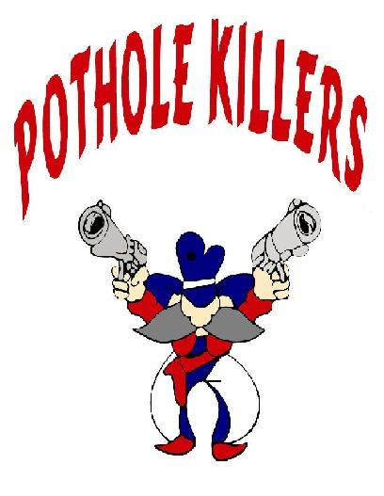 | (215) 949-9400 (office)

